Microbiology Intern – Summer 2023
Looking to kickstart your professional experience? Join us at John B. Sanfilippo & Son in Elgin, Illinois for an unforgettable internship in the food industry! You will gain meaningful experience, learn the business, and make an impact working in an area aligned to your major and interests. Customers and consumers across the country turn to John B. Sanfilippo & Son, Inc. (JBSS) as a food industry leader in nuts & snacks.
As a microbiology intern, you will have your own project as well as work in both a corporate and manufacturing setting in the food industry while applying your microbiology skills.
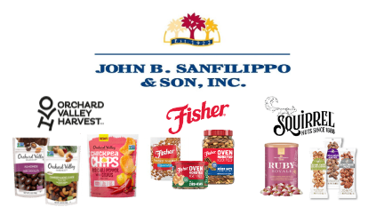
To learn more about this internship, check out our LinkedIn job posting: https://www.linkedin.com/jobs/view/3440911755
More information about our company and careers: https://jbssinc.com/careers/

